### Storage

Entities (synthesis parameters) extracted from each document are unique to the prep-sheet/report. But there is a need to link, organize and store the information extracted from prep-sheets/reports (Meta data, entities and entity relationships) to enable easy & effective search and query operations on the data.

Graphs provide an efficient way to **store** **relationships between entities** and **navigate** **through them easily**. A graph data model consists of **nodes/vertices** that represent the entities in a domain and its associated attributes, and edges that represent the relationships between these entities.

For example, if Alice, aged 40 years and Senior Executive in HR Team reports to Bob, aged 52 years and Manager in HR Team, then the graph will contain nodes (Alice and Bob) that are connected to each other by a relationship (‘reports_to’) and connected to their respective attributes such as Age, Designation and Team.

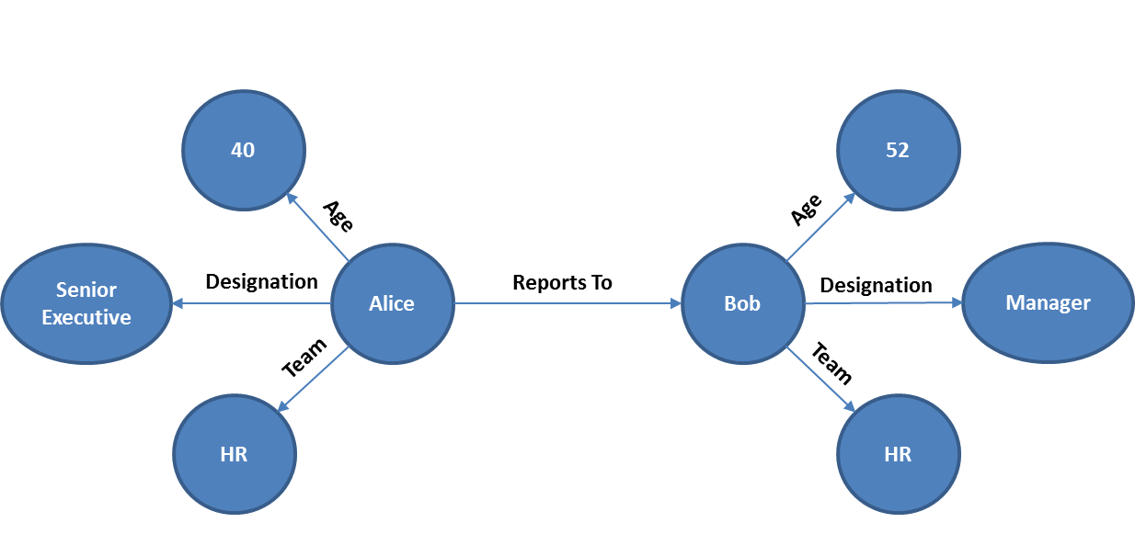

1. Graph (Example)

Now, let’s apply the concept of graph on a prep sheet and illustrate how information from them shall be stored.

1. CNE-2015-30631 and its Key attributes
2. CNE-2015-30631 and its Precalcination and Ammonium Exchange process
3. CNE-2015-30631 and its Steaming processes
4. **CNE-2015-30631 and its key attributes**

Following is a sample of extracted information from Prep-Sheet CNE-2015-30631 -

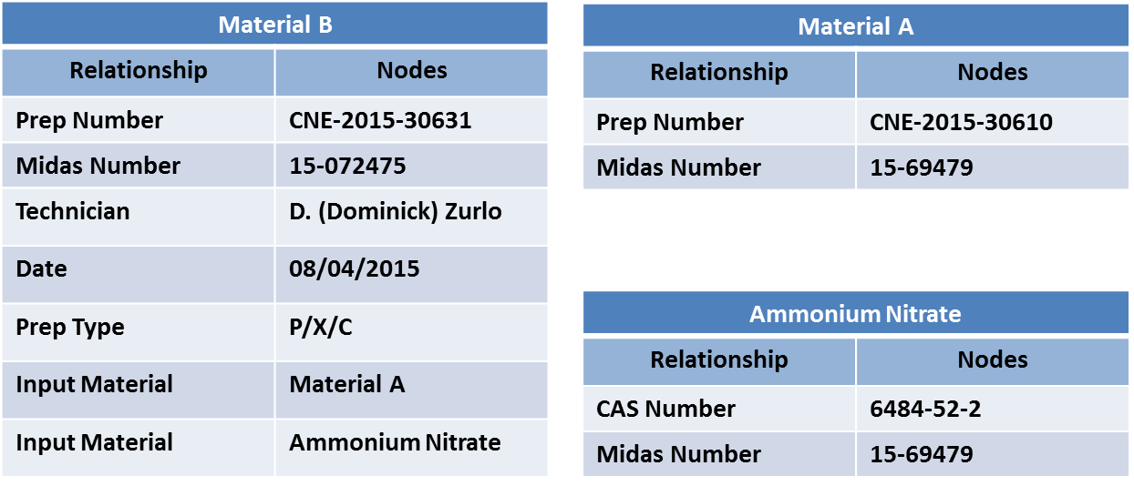

1. Relationship and Nodes Example (Illustration)

Material B is the output material. Material A and Ammonium Nitrate are the parent materials for synthesizing Material B. Relationship between Material A & B, attributes of Material B such as Prep Number ‘CNE-2015-30631’, Prep Type ‘P/X/C’, and so on are captured as nodes and edges as shown in Figure 16

**Material A (Parent Material):** 0.03%Pt/6XCu (40% metal to ZSM-5, 60% metal to MOR) 45/25/30 MCP1470C SGM-7575/MCP440L/V300

**Material B (Output Material):** P/X/C 0.03%Pt/6XCu (Muller, 40% metal to ZSM-5, 60% metal to MOR)/45/25/30 MCP1470C/MCP440L/Alumina

Below graph is an example of how the above information from Prep-Sheet CNE-2015-30631 is represented as nodes and relationships –

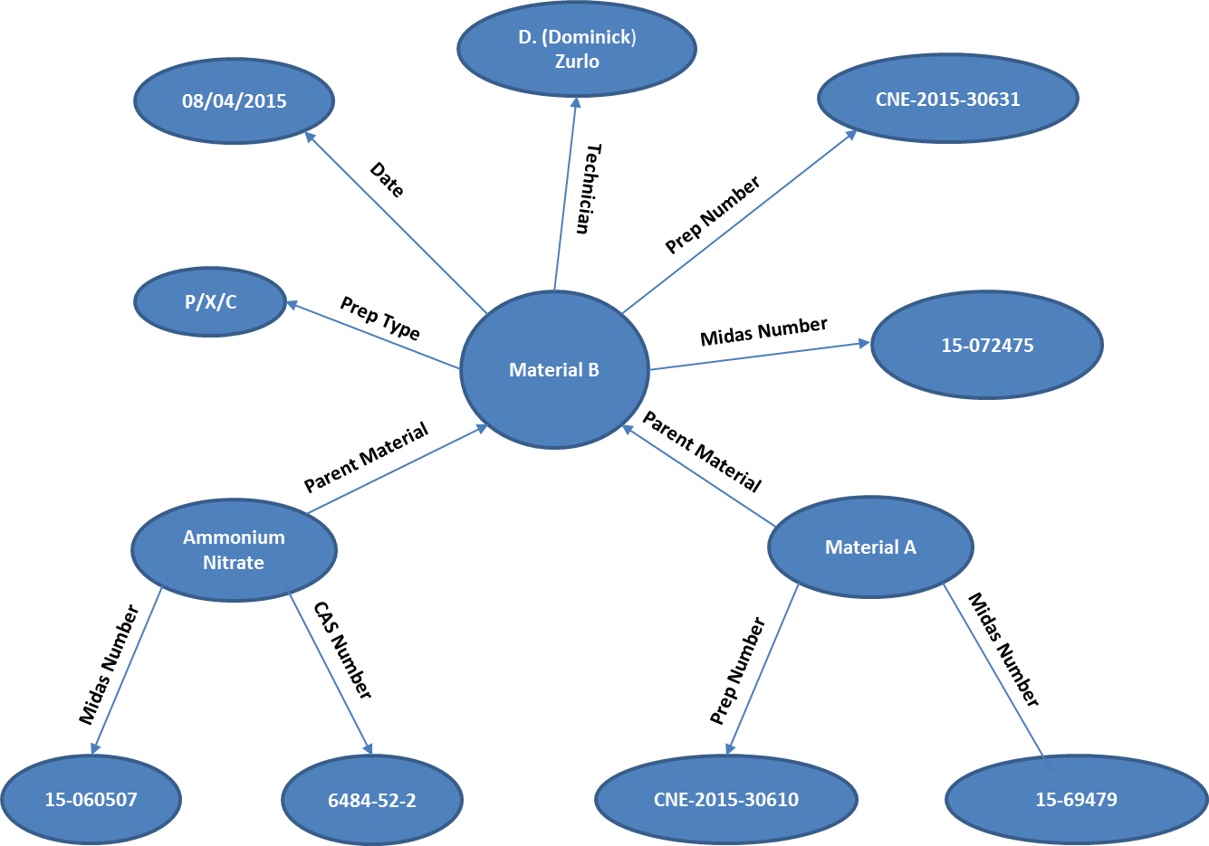

1. Sample Graph (Illustration)
2. **CNE-2015-30631 and its Precalcination and Ammonium Exchange process**

Following is a sample extract from Prep-Sheet CNE-2015-30631 on how a P/X/C procedure is performed –

* Perform Precalcination on 532.34 g of Parent Material A
* Perform Ammonium Exchange by adding 2,309.5 ml of Ammonium Nitrate to 461.90 g of the precalcined extrudate
* Repeat exchange with Ammonium Nitrate thrice and Calcine to arrive at the Final Material B

Below is the graph representation of the above mentioned P/X/C procedure –

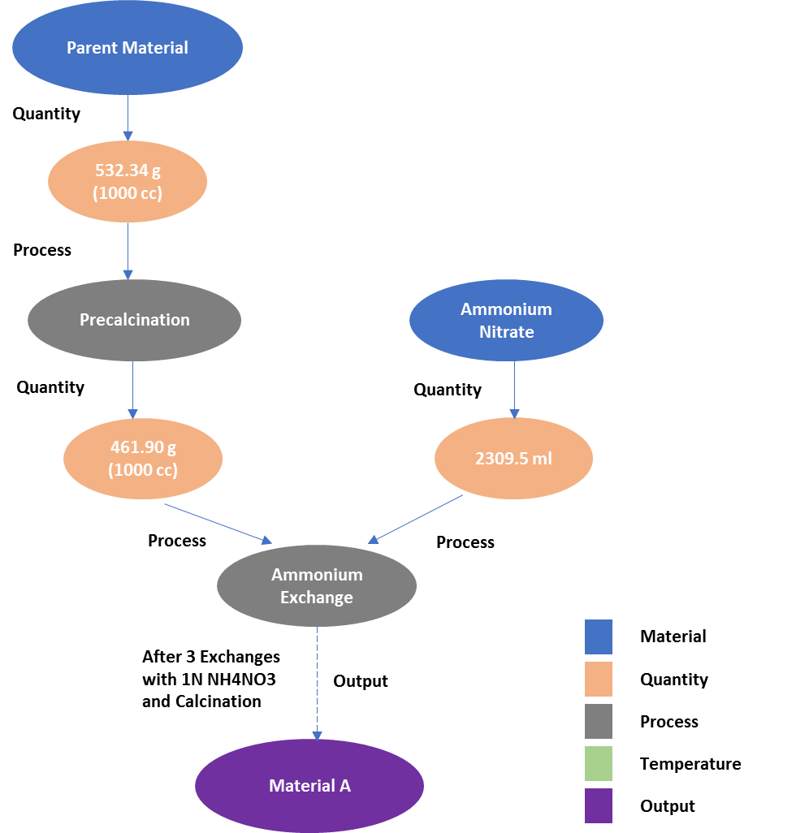

1. P/X/C Procedure (Illustration)
2. **CNE-2015-30631 and its Steaming process**

Following is a sample extract from Prep-Sheets CNE-2015-30635, CNE-2015-30632 and CNE-2015-30633 on how a steaming procedure is performed on the same parent material to synthesize 3 different materials –

* Take 60 g of the Material A
* Steam Material A at
  1. Temperature 650 F for 8 hours at 100% to arrive at the Material B1
  2. Temperature 600 F for 4 hours at 100% to arrive at the Material B2
  3. Temperature 700 F for 4 hours at 100% to arrive at the Material B3

Below is the graph representation of the above mentioned steaming procedure –

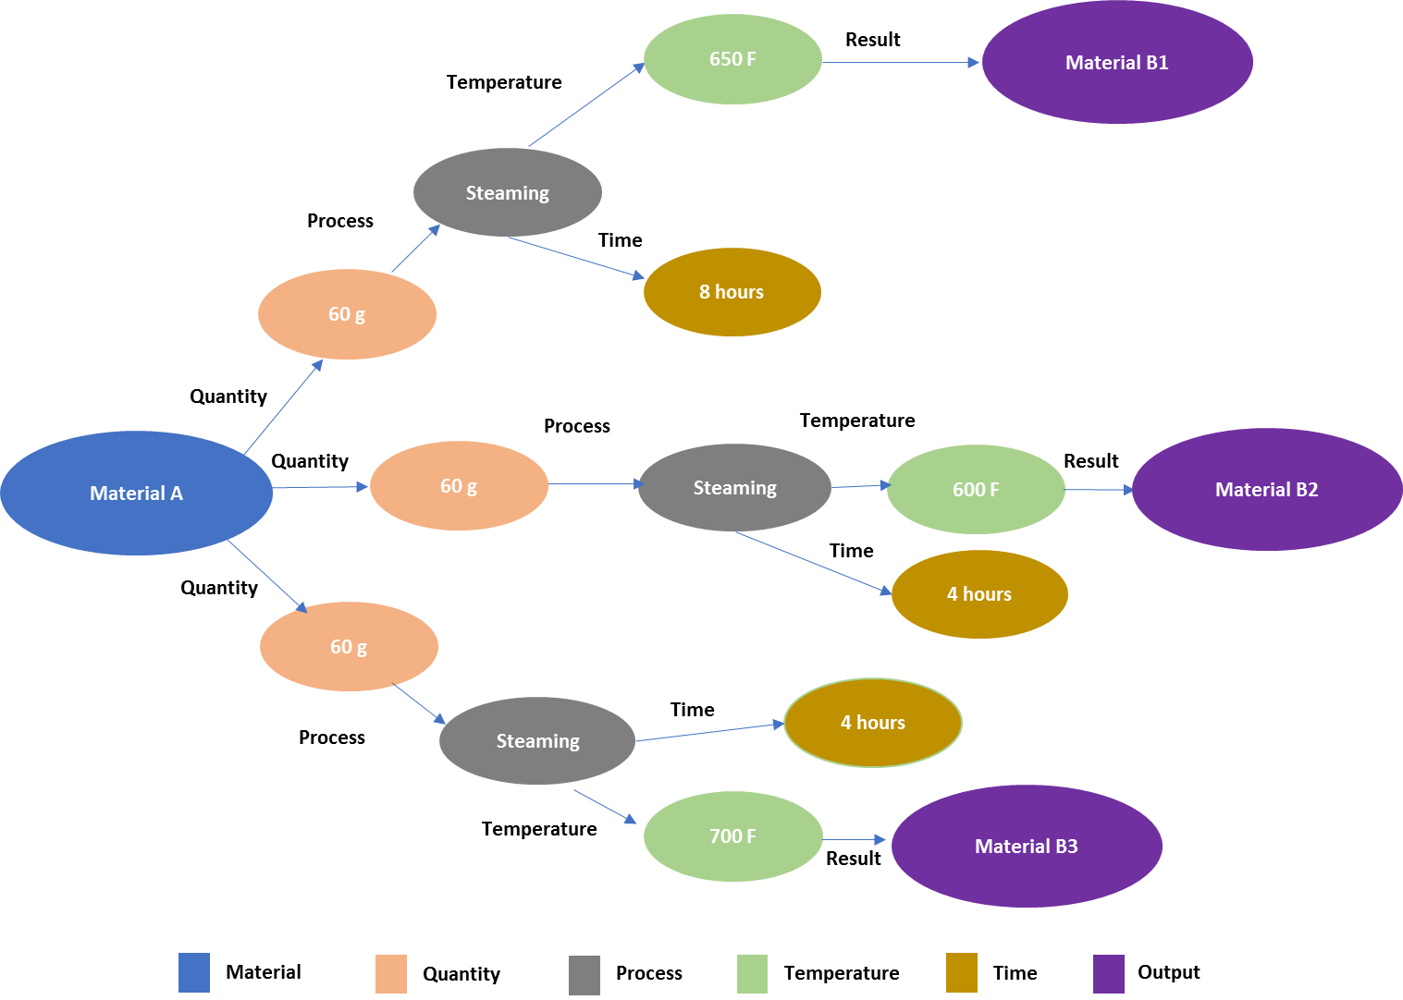

1. Steaming Procedure (Illustration)

**Material A :** P/X/C of 0.03%Pt/6XCu (Muller, 40% metal to ZSM-5, 60% metal to MOR)/45/25/30 MCP1470C/MCP440L/Alumina

**Material B1:** Steaming (8h@650F)/0.03%Pt/6XCu (Muller, 40% metal to ZSM-5, 60% metal to MOR)/45/25/30 MCP1470C/MCP440L/Alumina

**Material B2:** Steaming (4h@600F)/0.03%Pt/6XCu (Muller, 40% metal to ZSM-5, 60% metal to MOR)/45/25/30 MCP1470C/MCP440L/Alumina

**Material B3:** Steaming (4h@700F)/0.03%Pt/6XCu (Muller, 40% metal to ZSM-5, 60% metal to MOR)/45/25/30 MCP1470C/MCP440L/Alumina